Statistics Consulting on Thesis Proposal Work

1. Research Question

2. Methods

3. Analysis and Results (anticipated, sample size) using simulations

**Project Goals:**

What is the relationship of gluteus medius muscle activity and strength in female distance runners with ITB; and can stretching, conventional hip rehab, or experimental rehab improve gluteus medius function?

**Proposed Methodology:**

Participants will be randomly selected from patients presenting to <FILL_IN> Clinic with a history and positive physical exam finding for ITBS. The population will consist of female distance runners 18-45 years of age. All female distance runners will participate on a volunteer basis. The overall sample for the study will be composed of recreational female runners, defined as averaging a minimum of 10 miles per week for the past 3 months, not competing on a team at the high school, college or professional level, and not competing for a team in a marathon or distance races. Age, gender, leg of injury, pain, body weight, and height will also be measured. Participants will be split into 3 treatment groups conventional stretching (treatment A), conventional hip rehab (treatment B), and experimental rehab (treatment C). Measurements will be collected for GM strength (dynamometer), single mini leg squats, Y balance, and VAS.

Response variables:

There are a total of 4 dependent variables that are measured at different time points over a 10 week period. They are the following,

|  |  |
| --- | --- |
|  | Time of measurement |
| Y balance | week 0 and week 8 |
| DN | weeks 0, 2, 4, 6, 8 (biweekly) |
| Single mini leg squats | weeks 0, 8 |
| VAS | weeks 0, 1, 2, … 8 (weekly) |

Control variables:

Age, gender, leg of injury, pain, body weight, and height will also be measured for each participant.

Treatment variables:

There are a total of three treatments (rehabilitation methods): conventional stretching (treatment A), conventional hip rehab (treatment B), and experimental rehab (treatment C).

**Analysis**

We will perform separate analyses for each of the four response variables. Since measurements on the same subjects will be taken at different time points, we will fit a two way factorial repeated measures ANOVA model, where the repeated measures are within the time factor of measurements. The two factors are treatment and time of measurements. We can further control for variability between subjects by including age, gender, leg of injury, etc. in our model. If we determine a significant difference between the treatment effects, we can further perform pairwise tests between treatments of interests. For pairwise tests of response variables of pre and post measurements, we first calculate the change from pre to post treatment. We then perform a one-sided t-test between each combination of two treatments. For pairwise tests of response variables of measurements by weeks, we calculate the average of the measures of all weeks. We then perform a one-sided t-test between each combination of two treatments.

**Results:**

We will experiment on the anticipated results on subjects for each of the three treatments. Y Balance of each subject is measured at pre and post treatment. We simulated data for thirty subjects at initial measures for each response for the first week before treatment. We then simulated post treatment or bi-weekly measures data for each subject.

**Anticipated Results:**

Under the repeated measures ANOVA model, we found a significant effect for a difference in treatment methods on Y Balance measures (p = 0.000318). Therefore, we further compare each of the three treatment methods through pairwise comparisons. We calculate the change from pre to post treatments, and then perform a one-sided t-test. We found a significant improvement of using experimental rehab as opposed to stretching (p = 6.455e-05). We also found a significant improvement using experimental rehab versus conventional rehab (p = 0.002546). However, we did not find a significant improvement by using conventional stretching as opposed to stretching (p = 0.1418). We see in the boxplots of main effect of treatment on Y Balance that on average the subjects who underwent the experimental rehab treatment do better. From the interaction plot, we see that there is a greater improvement of Y Balance measures by using experimental rehab over conventional rehab and stretching based on the post treatment outcomes.

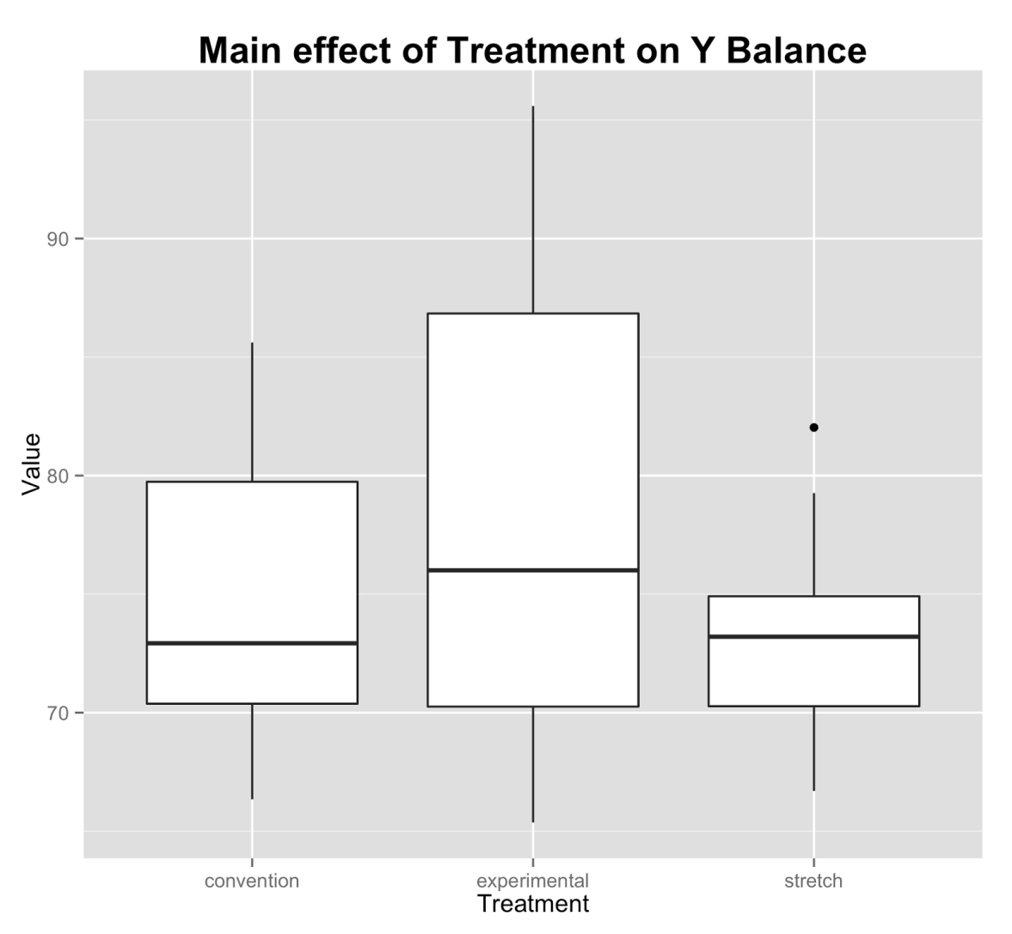

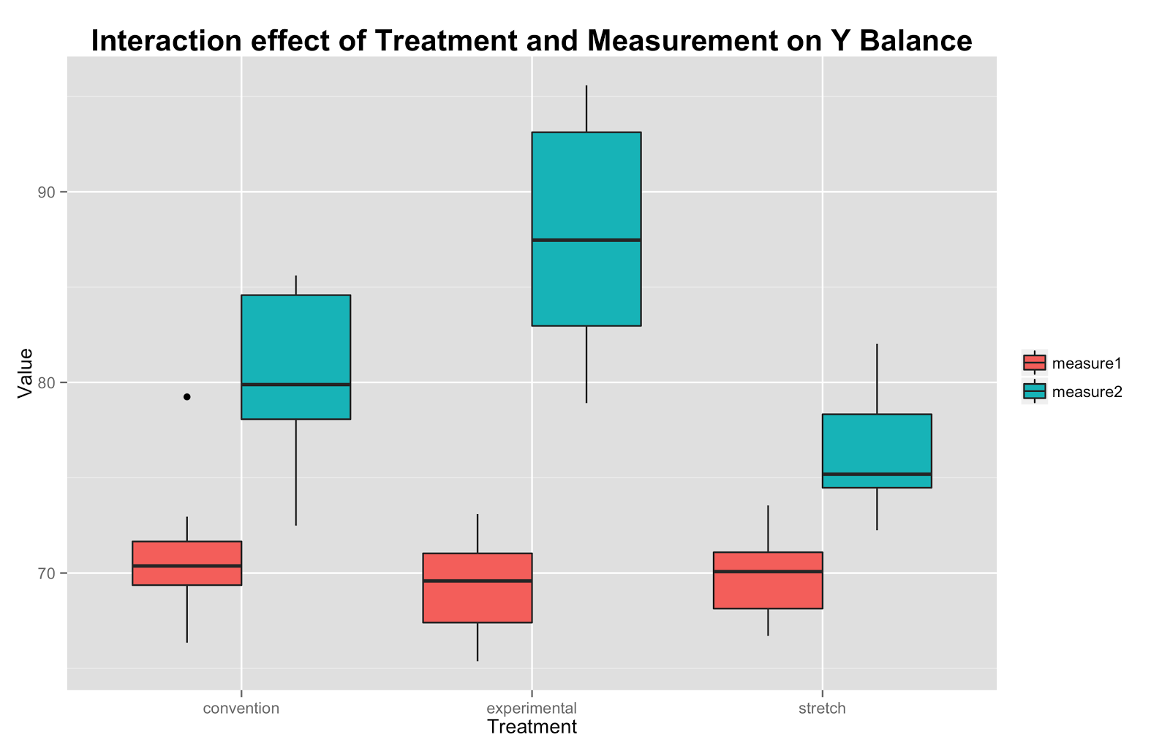

Under the repeated measures ANOVA model, we found a significant effect for a difference in treatment methods on Single Mini Leg Squats measures (p = 6.84e-08). Therefore, we further compare each of the three treatment methods through pairwise comparisons. We calculate the change from pre to post treatments, and then perform a one-sided t-test. We found a significant improvement of using experimental rehab as opposed to stretching (p = 4.417e-05). We also found a significant improvement using experimental rehab versus conventional rehab (p = 0.00752). We also did find a significant improvement by using conventional stretching as opposed to stretching (p = 0.0004921). We see in the boxplots of main effect of treatment on single mini leg squats that on average the subjects who underwent the experimental rehab treatment do better. From the interaction plot, we see that there is greater improvement of single mini leg squats measures by using experimental rehab over conventional rehab and stretching based on the post treatment outcomes.

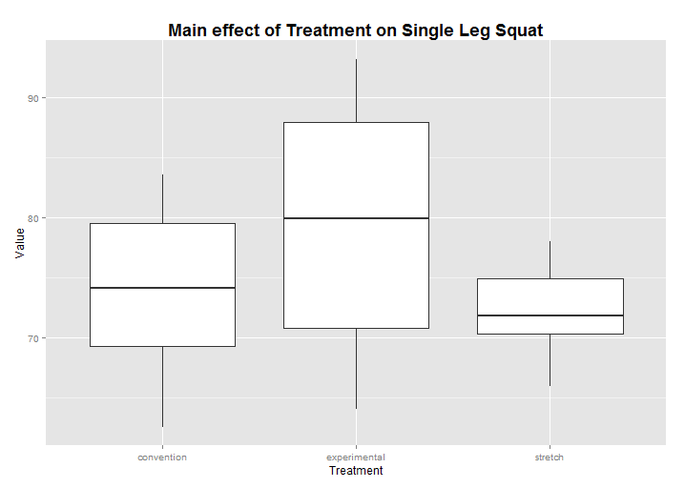

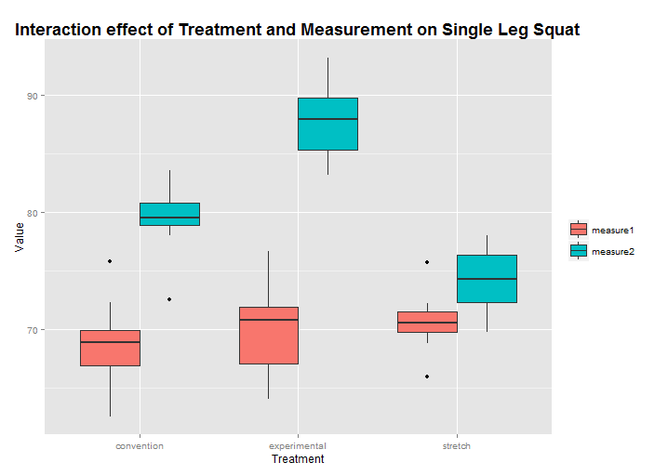

Under the repeated measures ANOVA model, we found a significant effect for a difference in treatment methods on DN measures (p = 3.12e-05). Therefore, we further compare each of the three treatment methods through pairwise comparisons. We calculate the average of all weeks of treatments, and then perform a one-sided t-test. We found a significant improvement of using experimental rehab as opposed to stretching (p = 0.0005833). We did not find a significant improvement using experimental rehab versus conventional rehab (p = 0.5577). However, we did find a significant improvement by using conventional stretching as opposed to stretching (p = 0.0001634). We see in the boxplots of main effect of treatment on DN that on average the subjects who underwent the experimental rehab treatment do better. From the interaction plot, we see that there is faster improvement of DN measures over the weeks by using experimental rehab over conventional rehab and stretching based on the post treatment outcomes.

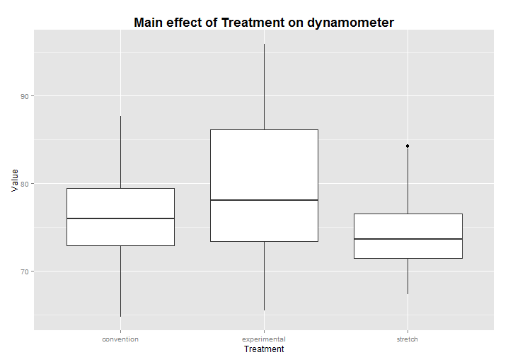

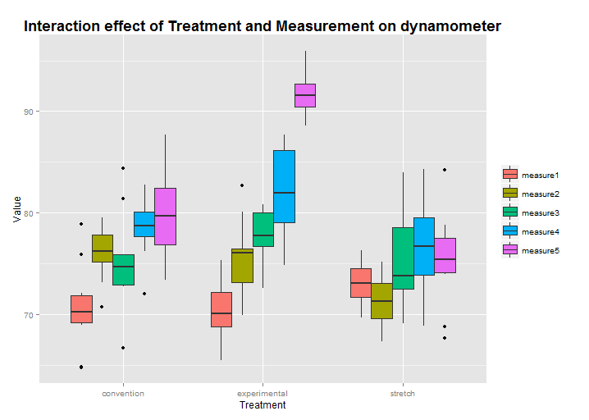

Under the repeated measures ANOVA model, we found a significant effect for a difference in treatment methods on VAS measures (p = 1.28e-07). Therefore, we further compare each of the three treatment methods through pairwise comparisons. We calculate the average of all weeks of treatments, and then perform a one-sided t-test. We did not find a significant improvement of using experimental rehab as opposed to stretching (p = 0.2655). We did not find a significant improvement using experimental rehab versus conventional rehab (p = 0.9302). However, we did find a significant improvement by using conventional stretching as opposed to stretching (p = 0.01359). We see in the boxplots of main effect of treatment on VAS that on average the subjects who underwent the experimental rehab treatment do better. From the interaction plot, we see that there is a faster improvement of VAS measures over the weeks by using experimental rehab over conventional rehab and stretching based on the post treatment outcomes.

